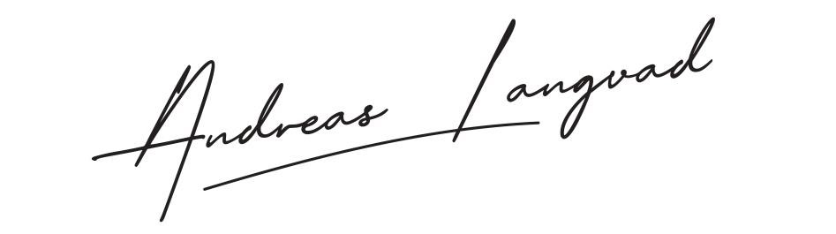
HOSPITALITY RIDER Artist: Andreas Langvad
Event:
Members
 | NAME | ROLE | Attending event?
1 | Andreas Langvad | Musician
2 | Søren Holm | Musician
3 | Albert Iversen | Musician
4 | Lukas Dreyer | Musician
5 | Mogens Petersen | Manager
6 | Laura Schøder | Photographer
7 | Trine Mortensen | Runner

List of food/beverage needed for each member of the team as minimum.
- 2 bottles of water
- 1 beer
- 1 soft drink or juice
- 1-3 meals per day depending on the event’s duration.

Contact regarding hospitality: | Name: | Andreas Langvad
 | Tel.: | +45 31 77 58 73
 | Email: | andreaslangvad@hotmail.com

Special needs/allergies etc.:
- A
- The requirements must be met each day during the event.

